**REINSURANCE FLOW**

**Step 1:** Cedant requests Broker to raise a claim for the insured contract

Broker

Cedant

**Step 2:** Broker feeds the details collected form the Cedant to process the claim



**Step 3:** The technical team will assess created Claim based on the Claim Types Account/Memo/Regular/Workers Compensation.

Technical team takes survey based on the appropriate controllers, and submits to Claim analyst.

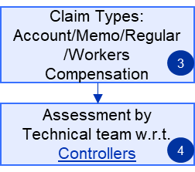

**Step 4:** Once assessment is done by the technical team,

Based on the authority limits Claim Analyst will approve the claim

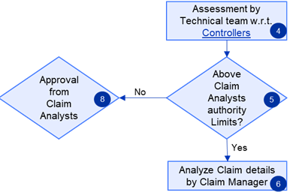

**Step 5:** If the claim amount exceeds the authority limits then, it is forwarded to the claim manager to analyze the claim details. Claim manager have all the authority to either approve or reject the Claim.

If Claim manager approves the claim then, it is sent to generate Invoices based on Disbursement.

If Claim manager needs additional information, he requests broker for the details in order to process the claim.

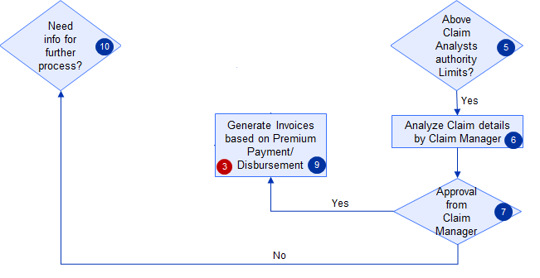

**Step 6:** If the claim amount is less than the authority limits, it is sent to the approval of the claim analysts. Claim analyst may approve or reject the claim amount.

If claim analyst approves then it is sent to generate Invoices based on Premium Payment/Disbursement.

If Claim analyst needs additional information he requests broker for the details in order to process the claim.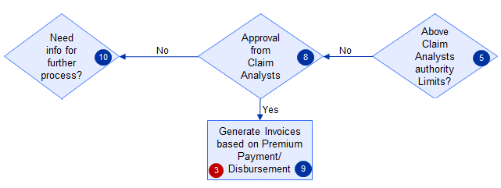

**Step 7:** Once Claim authority receive additional information from broker, he have authority to decline the claim or approve claim based on appropriate details provided.

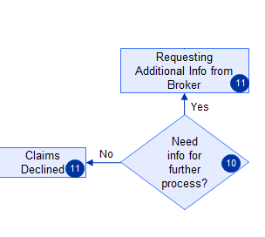

**Step 8:** If the details are inappropriate /not provided, then the Claim analyst will decline the Claim and comment them for the future reference.

